A B2B MOBILE ECOMMERCE APP

Content Pages

CHAPTER ONE INTRODUCTION 1

1.1 Background of Study 1

1.2 Statement of the Problem 1

1.3 Aim and Objectives of the Study 2

1.4 Scope of the Project 2

1.5 Limitation of the Study 2

1.6 Significance of the Study 2

1.7 Project Organization 2

CHAPTER TWO LITERATURE REVIEW 3

2.1 Introduction 3

2.2 Programming Languages Used 3

2.2.1 Low Code 3

2.3 Related Literature 3

**2.3.1** Definition of E-commerce 3

**2.3.2** History of Ecommerce 5

**2.3.3** Different types of E-commerce 6

**2.3.4** E-commerce Usage in Developed vs. Developing Countries 7

CHAPTER THREE PROPOSED METHODLOGY 10

3.1 Introduction 10

3.2 Number of modules of e-commerce application 10

3.3 Analysis Models 10

3.3.1 Use Case Diagram 10

3.3.2 Data Flow Diagram 11

3.3.3 Sequence Diagram 11

3.3.4 Entity-Relationship Diagram 12

3.3.5 Architecture Diagram 13

3.4 Programming languages used 14

# CHAPTER ONE INTRODUCTION

## Background of Study

Low-code is a software development approach where developers develop applications in a graphical interface. Rather than writing thousands of lines of complex code and syntax, low-code developers drag and drop visual models to create complete applications with modern user interfaces, integrations, data, and logic. The result? Organizations get apps into production much faster.

Internet has contacted our lives from such a large number of points. One of the critical zones of day by day lives where it is profoundly influenced is matter of fact. Online business is where Information Technology (IT) and business exercises are merging into one another. It is a plan of action, or fragment of a bigger plan of action, that empowers a firm or individual to direct business over an electronic system, ordinarily the web (SAHA, 2018).

In this virtual time, a relevant online business procedure is the way to long haul sustenance for any business. Today, pretty much each and every errand is done through on the web and shopping is no exemption. Having a web based business site is no more a way to accomplish upper hand. It is a vital basic for business, while customers are now flourishing on the web (SAHA, 2018).

Internet based business is quick making progress as an acknowledged and utilized business worldview. More entrepreneurs executing web based business usefulness and online exchange framework into their sites. So it isn't difficult to state that into couple of decades web will be the typical for shopping any sort of item or administrations (SAHA, 2018).

The goal of this project is to expand a modern dynamic e-commerce internet software as online or digital store on the net. Where one of a kind varieties of product may be offered from the consolation of domestic through the internet.

## Statement of the Problem

As per an ongoing report by User Study and Experience Research Hub (Userhub) there is no single internet business webpage accessible in Nigeria that is completely consistent with universally settled web measures. The gathering of specialists who led the examination, which was centered around the commonness of Accessibility Errors, Accessibility Alerts, and Contrast Errors, and HTML and CSS approval. This test has been done on 174 dynamic internet business destinations recorded with the web-based business Association of Bangladesh (e-CAB). The specialists utilized W3C prescribed instruments and arbitrarily chosen 3 pages of every site for the testing reason on above issues.

The consequences of the examination demonstrated that, in Nigeria there were no single internet business locales with zero blunders and alerts. The normal commonness of openness blunders was 60.57, HTML mistakes 49.52, and CSS mistakes 27.16 (SAHA, 2018). This kind of related news inspired me to do the venture.

## Aim and Objectives of the Study

Is to develop a modern responsive ecommerce web application using low code approach.

The objectives are:

1. An engaging and easy to use UI with good UX.
2. The logic will be handled and the data will be stored in a low code framework.
3. Provide refund function with stripe api.
4. Allow B2D for the developer side.
5. Evaluating and verifying the app.

## Scope of the Project

This will be a multi shop ecommerce app allowing user to upload multiple products with their corresponding inventory and price.

## Limitation of the Study

This will be only on a local host as the web application is design for an undergraduate program.

## Significance of the Study

The platform or web app stands to bring a responsive and user experience interface design for user to facilitate easy use of the platform. Which also allows admin to monitor employees performance and also email customers based on their orders or on discount & offers.

## Project Organization

The project is made up of three chapters. Chapter one summarizes the introductory study on ecommerce applications, including the background of study, statement of the problem, aim and objectives, significance of the study, scope of the study and limitation of the study. Chapter Two is the review of related literature. Chapter three is proposed methodology.

# CHAPTER TWO LITERATURE REVIEW



## Introduction

A look at what the programming language and database used the project are and a review of related literature.

## Programming Languages Used

### Low Code

A low-code platform removes the repetitive and tedious tasks like dependency management, code validation, and complicated builds by automating them and other mundane aspects of development (Buttles, 2022).

Developers can focus on the creative extra mile that makes a difference in their applications and to the business instead of just keeping the lights on (Buttles, 2022).

## Related Literature

In this secion, literature from different sources (books, research paper and internet websites) on the ecommerce history, business model and comparative study has been discussed for better application development process. History of ecommerce says that web based shopping just wound up conceivable when the web was opened to general society in 1991. Amazon.com was one of the principal ecommerce destinations in the US to begin offering items on the web and a large number of organizations have pursued since. The tremendous fame of the web as of late has been powered generally by the possibility of performing business on the web. With the quick worldwide development in electronic trade, organizations are endeavoring to pick up an upper hand by utilizing internet business to interface with clients.

### Definition of E-commerce

There are numerous definitions for E-commerce which share a ton for all intents and purpose. By the by E-business has been characterized by researchers and specialists in various ways. Web based business alludes principally to the purchasing and offering exercises over the Internet, which incorporates exchanges, for example, setting orders, making installments, and following conveyance of requests on the Internet (Rodgers, 2002). The web based business is characterized as purchasing and offering of item administration or data through PC organizes mostly the web (Wen et al., 2001, as cited by SAHA, 2018) and individuals instantly consider shopper retail buys from organizations, for example, Amazon (Chaffey et al, 2006, as cited by SAHA, 2018). Be that as it may, internet business alludes to both monetary and educational electronically intervened exchanges between an association and any outsider it manages (Chaffey, 2006, as cited by SAHA, 2018). Further, Singh (2001, as cited by SAHA, 2018) upheld the definition by alluding web based business to an online administration offered to client to help their shopping knowledge over the web.

Online business is exponentially expanding the accessibility of data, giving clients access to more information, of preferable quality and quicker over previously. Mechanical headway drove an unstable improvement in electronic business, the reasons for that are the web end the World Wide Web (WWW), which are making electronic trade considerably more available. Web internet business incorporates electronic exchanging of physical merchandise and of intangibles, for example, data. This incorporates all the exchanging steps, for example, web based promoting, requesting, installment and support for conveyance (Trimmers, 2000, as cited by SAHA, 2018).

Online business is utilized wherever in regular daily existence. Presently a days it is used for everything from Visa approval, travel reservation over a system, wire support exchanges over the world, purpose of offer (POS) exchanges in retailing, electronic managing an account. It helps in create interest for the items and benefits and enhances arrange the executives, installment and other help capacities (Awad, 2004, as cited by SAHA, 2018). Thus, online business diminishes the expense of making, preparing, disseminating and recovering paper based data. Further encourages the advantages which incorporate enhanced picture, enhanced client benefit, streamlined procedures, packed cycle and conveyance time, disposing of printed material and expanded adaptability (Turban et al, 1999, as cited by SAHA, 2018).

Additionally, online business isn't just about purchasing and offering as it is likewise about electronically imparting, teaming up and finding data (Turban et al, 2004, as cited by SAHA, 2018). It can include the Internet, groupware programs, open email systems (Adams, 1994, as cited by SAHA, 2018), innovations, for example, electronic information trade (EDI) and electronic supports exchange (EFT) and all the more as of late, administrations related with cell phones and computerized TV (Voss, 1999, as cited by SAHA, 2018). E – Business has turned out to be exceptionally well known due to the advantages and accommodation it brings along as it is not any more an option, it is a goal (Wen et al, 2001, as cited by SAHA, 2018). E-trade is by and large dependent on financial exchange and e-administrations are the piece of electronic trade, as cited by (SAHA, 2018).

### History of Ecommerce

The historical backdrop of web based business begun 40 years prior and, right up 'til today, keeps on developing with new technological advancements, innovations, and a huge number of organizations entering the online market every year (SAHA, 2018).

Electronic Data Interchanges and mail order shopping during the 1970s made ready for the present day internet business store. The historical backdrop of online business is nearly entwined with the historical backdrop of the web. Web based shopping just ended up conceivable when the web was opened to the general population in 1991 (SAHA, 2018).

Web based shopping was designed and spearheaded in 1979 by Michael Aldrich in the United Kingdom. He associated an adjusted local TV by means of a phone line to an ongoing multi-client exchange handling PC (SAHA, 2018). The framework was promoted starting in 1980 and offered fundamentally business-to-business frameworks that were sold in the UK, Ireland, and Spain. One the most punctual purchaser shopping encounters was Book Stacks Unlimited, an online book shop made by Charles M. Stack in 1992 (SAHA, 2018). Stack's store started as a dial-up release board two years previously Amazon was established by Jeff Bezos. In 1994, Book Stacks Unlimited moved to the Internet as Books.com and was eventually acquired by Barnes & Noble (SAHA, 2018).

The main online exchange was, by a few reports, marijuana sold by Stanford students to MIT students by means of the Arpanet account at their artificial intelligence lab in 1972 (SAHA, 2018). In any case, the primary web based shopping exchange on the Internet occurred exactly 22 years after the fact. With the feature "The Internet is Open", the August 12, 1994, issue of New York Times chronicled the deal between two companions of a Sting CD. The Times said, “The team of young cyberspace entrepreneurs celebrated what was apparently the first retail transaction on the Internet using a readily available version of powerful data encryption software designed to guarantee privacy (SAHA, 2018).”

History of online business is unimaginable without Amazon and eBay which were among the principal Internet organizations to permit electronic exchanges. Because of their originators we presently have an attractive web based business area and appreciate the purchasing and offering points of interest of the Internet (SAHA, 2018).

Amazon is one of the primary web based business organizations to build up a partner promoting system, and these days the organization gets about 40% of its deals from associates and outsider venders who rundown and offer products on the site. In 2008 Amazon entered into the film and is right now supporting the film "The Stolen Child" with twentieth Century Fox (SAHA, 2018).

As per the exploration led in 2008, the space Amazon.com pulled in around 615 million clients consistently. The most well-known component of the site is the audit framework,

i.e. the capacity for guests to present their audits and rate any item on a rating scale from one to five stars. Amazon.com is additionally outstanding for its clear and user-friendly advanced search facility which empowers visitors to search for keywords in the full content of numerous books in the database (SAHA, 2018).

### Different types of E-commerce

The E-trade exchanges occur between opposite sides of an exchange. The sides of this exchange can be a customer, a business, inner or the administration. At the point when the transaction is between the business and the consumer, it is called B2C. The transaction between businesses is called B2B E-commerce (SAHA, 2018). For the same reason the when E-commerce happens between business and government, it is called B2G and C2C for consumer to consumer (SAHA, 2018).

The following table is a quick demonstration of different types of existed E-commerce/E- businesses (SAHA, 2018).

* Not easy to classify
* Many real models fall into multiple categories

TABLE 2.1: EXAMPLE OF DIFFERENT TYPE OF THE E-COMMERCE

|  |  |  |
| --- | --- | --- |
| **B2B**  Business to Business   * PayPal (and B2C, B2B2C) * Optize (and B2C) * Alibaba Group | **B2C**  Business to consumer   * Amazon * FreshDirect * Zynga (and C2C) | **B2G**  Business to Government   * E-Procurement |
| **C2B**  Consumer to Business   * ZonZoo * Fotolia * Google Adsense | **C2C**  Consumer to Consumer   * Prosper (P2P) * eBay * Facebook | **C2G**  Citizen to Government   * Agencia Tributaria (Tax agency online) |
| **G2B**  Government to Business   * E-Government * AEPM * Certificado Digital | **G2C**  Government to Citizen   * E-Government * eDNI * USA.gov (also G2B) | **G2G**  Government to Government   * Government Gateway * Schengen Information System |

### E-commerce Usage in Developed vs. Developing Countries

Online business can possibly enhance proficiency and efficiency in numerous regions and, accordingly, has gotten critical consideration in numerous nations. Be that as it may, there has been some uncertainty about the significance of web based business for developing countries (SAHA, 2018). The nonappearance of satisfactory fundamental infrastructural, financial and the absence of government national ICT systems have made a huge hindrance in the adoption and development of online business in developing countries. For web based business in developing countries, social issues also should be considered (SAHA, 2018).

Wu et al. (2020) paper combs the concept of C2B according to the relevant literature research, through the comparative analysis of the decision relationship between B2C and C2B, discusses the essential connotation of C2B electronic commerce, and analyzes the C2B conceptual misunderstanding existing in the application of e-commerce combined with practical cases. On this basis, the C2B application platform and the main bottlenecks that may exist in the application of electronic commerce are discussed. Finally, the solution strategy of C2B application bottleneck and the future trend of C2B application are discussed.

E-commerce is mainly divided into three types, but (Xu & Chen, 2020) mainly analyzes the application of big data technology in B2C e-commerce precision marketing pattern. Firstly, the notion and features of B2C e-commerce as well as the concept and characteristics of precision marketing mode are described. Secondly, this paper further analyzes some challenges faced by B2C e-commerce in the times of large data. Finally, taking China Amazon B2C electronic commerce as an example, this paper briefly analyzes the ratio of B2C e-commerce in China’s online retail B2C market share in the third quarter of 2017, which is 4.1%. This shows that B2C e-commerce is developing rapidly under the background of large data era.

Qwaider (2020) introduces the concepts of e-commerce application framework based on cloud computing, the development trend of cloud computing that adapts to the problem of e-commerce and the storage and distribution of resources. A proposed structure allows organizations to reduce costs through the effective implementation of ecommerce activities and solve the problem of large companies to improve e-commerce applications through cloud computing.

Agrawal & Dhar (2021) reported in this paper primarily focuses on India’s top B2C organizations and the role of definitive user experience elements in shaping the success of these organizations. A heuristic-based comparative study was conducted among the top e-commerce Web applications in order to identify unique features that contribute to a sumptuous user experience. The analytical study was backed up by user studies that report the expectation of the customers and their frustrations. The collective insights were then correlated to each platform’s market ranking and share with an objective to identify and analyze features, design cues and elements that contribute to their standing in the Indian market. In a nutshell, the qualitative study explores connections between market ranking, usability heuristics, and user study insights in order to prescribe design features, cues, and elements that benchmark the user experience framework for B2C applications in an Indian context. The insights elaborate on the current trends, gaps, and opportunity areas for B2C applications.

Defiesta et al. (2020) discusses the development of an ecommerce platform with inventory integration for a mining equipment supplier companies. Because of e-commerce's low barrier of entry, many vendors and distributors sell directly to customers. With this, there is an opportunity to automate the business processes of the mid-size mining equipment supplier company to improve the service and sales performance. In turn, it can ease the management profit of the distributor channel. The system produces an e-commerce web application that can be overall access by the administrator. Likewise, distributors and customers' accounts can be partly access through the web application. This research includes modules to improve the system such as admin module, vendor module, distributor module, customer module and IT management system.

# CHAPTER THREE PROPOSED METHODLOGY



## Introduction

This chapter covers the analysis models (data flow diagram, sequence, class and entity relationship diagram) of the project and the higher-level solution (programming language) approach used.

## Number of modules of e-commerce application

This E-commerce project is divided into 9 modules:

* + Registration Module
  + Products Browse Module
  + Products Search Module
  + Shopping cart Module
  + Shipping & Billing Module
  + Payment Module
  + Admin User Management Module
  + Admin Catalog Management Module
  + Admin Order Management Module

## Analysis Models

Analysis models is a technical representation of the system. It acts as a link between the system description and the design model. In Analysis Modelling, information, behavior, and functions of the system are defined and translated into the architecture, component, and interface level design in the design modelling.

### Use Case Diagram

Use-case diagrams **describe the high-level functions and scope of a system**. These diagrams also identify the interactions between the system and its actors. The use cases and actors in use-case diagrams describe what the system does and how the actors use it, but not how the system operates internally.

Figure 3.1: Use Case Diagram

### Data Flow Diagram

A data flow diagram (DFD) maps out the flow of information for any process or system. It graphically represents the flow of data in a business information system.

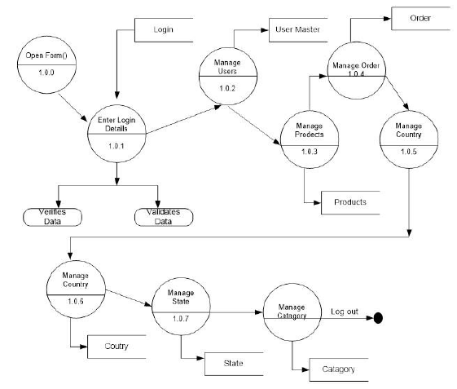

Figure 3.2: Data Flow Diagram

### Sequence Diagram

Sequence Diagrams are interaction diagrams that detail how operations are carried out. They capture the interaction between objects in the context of a collaboration.

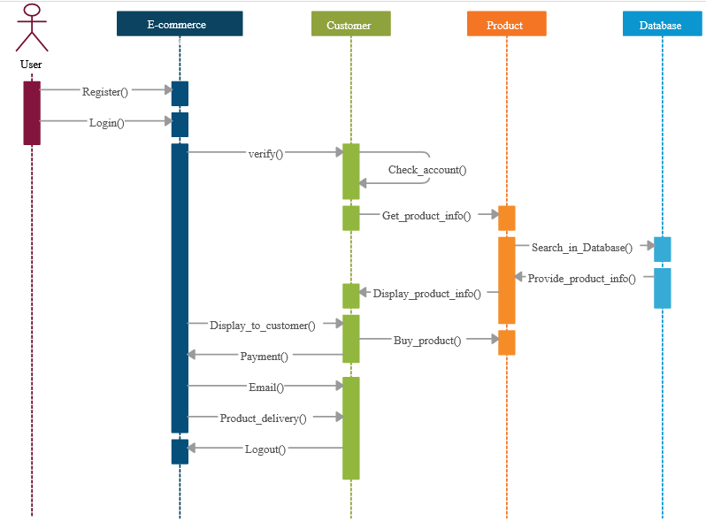

Figure 3.3: Sequence Diagram

### Entity-Relationship Diagram

An entity-relationship diagram (ERD) shows the relationships of entity sets stored in a database. An entity in this context is an object, a component of data. An entity set is a collection of similar entities. These entities can have attributes that define its properties.

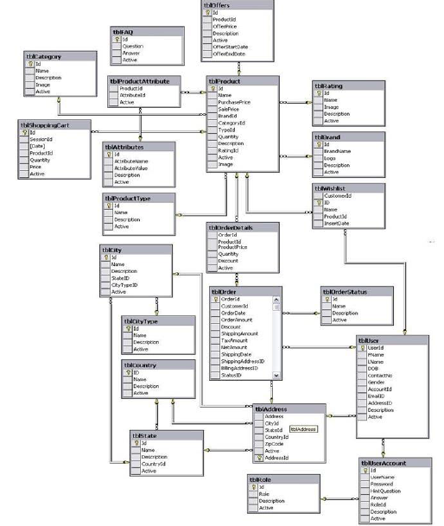

Figure 3.4: E.R Diagram

### Architecture Diagram

Class diagram is basically **a graphical representation of the static view of the system and represents different aspects of the application**. A collection of class diagrams represent the whole system. The name of the class diagram should be meaningful to describe the aspect of the system.

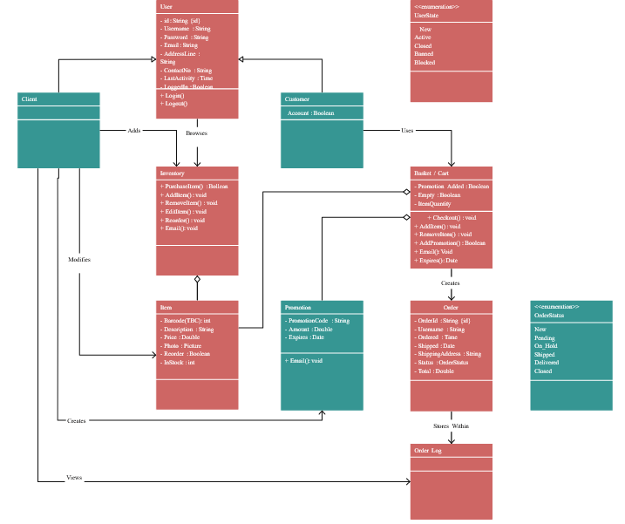

Figure 3.5: Class Diagram

## Programming languages used

* Low Code

REFERENCES

Agrawal, M., & Dhar, D. (2021). Enhancing user experience of e-commerce platforms—a case study of B2C applications in the Indian market. *Design for Tomorrow—Volume 1*, *1*, 503–516. https://doi.org/10.1007/978-981-16-0041-8_42

Buttles, B. (2022, November 24). *What is low code: Low code guide*. OutSystems. Retrieved December 24, 2022, from https://www.outsystems.com/guide/low-code/

Defiesta, M. L., Estrada, D. G., Veloso, A. N., Llesol, M. G., & Intal, G. L. (2020). B2B and B2C e-commerce platform for mining equipment suppliers. *Proceedings of the 2020 2nd International Conference on Management Science and Industrial Engineering*. https://doi.org/10.1145/3396743.3396772

Eisenman, B. (2015). *Learning react native*. O'Reilly Media.

Gadhavi, M. (2022, August 25). *What is Strapi? Strapi examples and why you should use it?* Radixweb. Retrieved December 24, 2022, from https://radixweb.com/blog/what-is-strapi

Hamishwillee, K & Ozgurturkiye, R. (2022). *Django Introduction - Learn Web Development: MDN*. Learn web development | MDN. Retrieved December 13, 2022, from https://developer.mozilla.org/en-US/docs/Learn/Server-side/Django/Introduction

Qwaider, W. Q. (2020). A Conceptual Model for E-Commerce Applications based a Cloud Computing. *International Journal of Computer Applications (0975 – 8887)* , *176*(13), 18–22.

Saha, S. (2018). *Implementation Of An E-Shopping Website* (thesis). Daffodil International University, Daffodil Smart City.

Wu, Q., Ma, J., & Wu, Z. (2020). Consumer-driven e-commerce: A study on C2B applications. *2020 International Conference on E-Commerce and Internet Technology (ECIT)*. https://doi.org/10.1109/ecit50008.2020.00019

Xu, G., & Chen, Q. (2020). On the application of large data technology in B2C E-Commerce Precision Marketing Mode. *Advances in Intelligent Systems and Computing*, 1197–1203. https://doi.org/10.1007/978-981-15-2568-1_166